Document Management: Final Assignment

Instructions

1. Four practical assignments are to be completed for this assessment. You must attempt all four components.

Assignment 1: Document for correction (20 Marks)

Assignment 2: Display – An Advertisement (20 Marks)

Assignment 3: Application Form (20 Marks)

Assignment 4: Mail Merge (30 Marks)

Presentation: 10 Marks

1. All tasks require proofreading; correct all errors in spelling, punctuation and grammar.
2. Ensure that all assignments are displayed on a single page (with the exception of Assignment 4, which requires six pages).
3. All abbreviations should be typed in full, where appropriate.
4. In the absence of specific instructions block or centre style is acceptable once used throughout a task.
5. Make sure that your name and student number are on every page in the header section. The footer of each page should contain a page number.
6. Assemble your completed work as one long document in the order that it is presented in this paper. Ensure that your headings Assignment 1-4 are formatted as Heading 1 style.
7. Complete a cover page with your course and module title, your name and date of submission.
8. Include an automatically generated Table of Contents on the second page of your submission.
9. Print your completed document, staple the pages together and give it to your lecturer on (or before) deadline.

**Checklist of pages required**

Cover Page

Table of Contents

Assignment 1: Details

Assignment 2: Advert

Assignment 3: Application

Assignment 4: Merge Template, Teachers

**Checklist of files to upload to Moodle**

Final Assignment.docx

Datafile.mdb

# Assignment 1

1. Create a new Word document. Enter a cover page as outlined above.
2. Insert a table of contents on page 2.
3. Insert the heading Assignment 1: Details at the top of page 3. Format it as Heading 1.
4. Save the document as Final Assignment.
5. Type the document below on page 3 of your Final Assignment. Incorporate the changes and additions indicated as a single page.
6. In the absence of specific instructions use left and right margins of 2.5cm.
7. Take care of pagination.
8. Proofread and correct where necessary. Pay particular attention to spelling and grammatical errors.
9. Insert your name and student number as a header.
10. Save the document.

# Assignment 1: Details

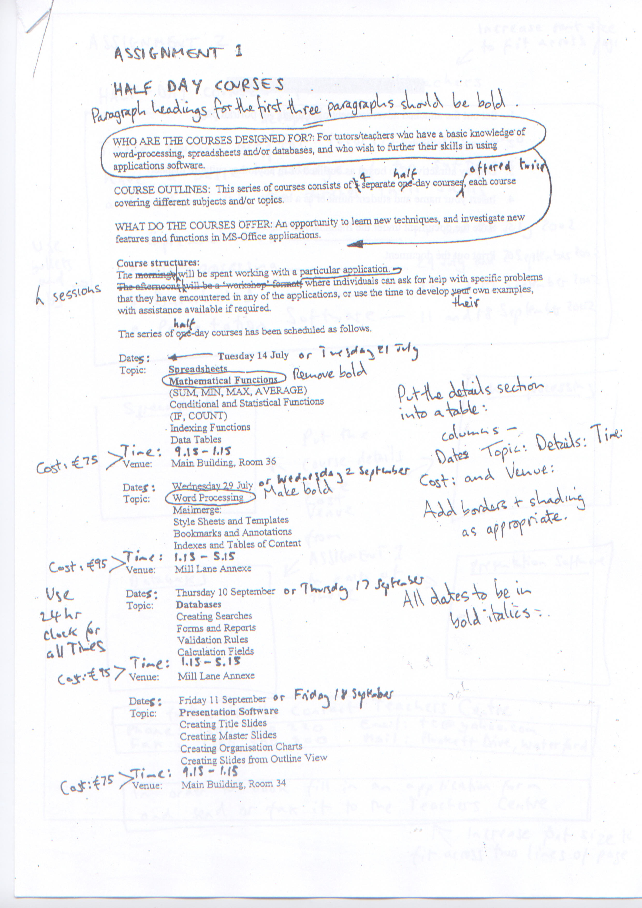

# Assignment 2

1. Open your Final Assignment document.
2. Insert the heading Assignment 2: Advert at the top of page 4. Format it as Heading 1.
3. Set out the advertisement (below) on a single A4 portrait page of your Final Assignment document.
4. Amend as indicated.
5. Display attractively in boxes as outlined or in any other suitable manner.
6. Take care of pagination.
7. Proofread and correct where necessary. Pay particular attention to spelling and grammatical errors.
8. Insert your name and student number as a header.
9. Save the document.

# Assignment 2: Advert

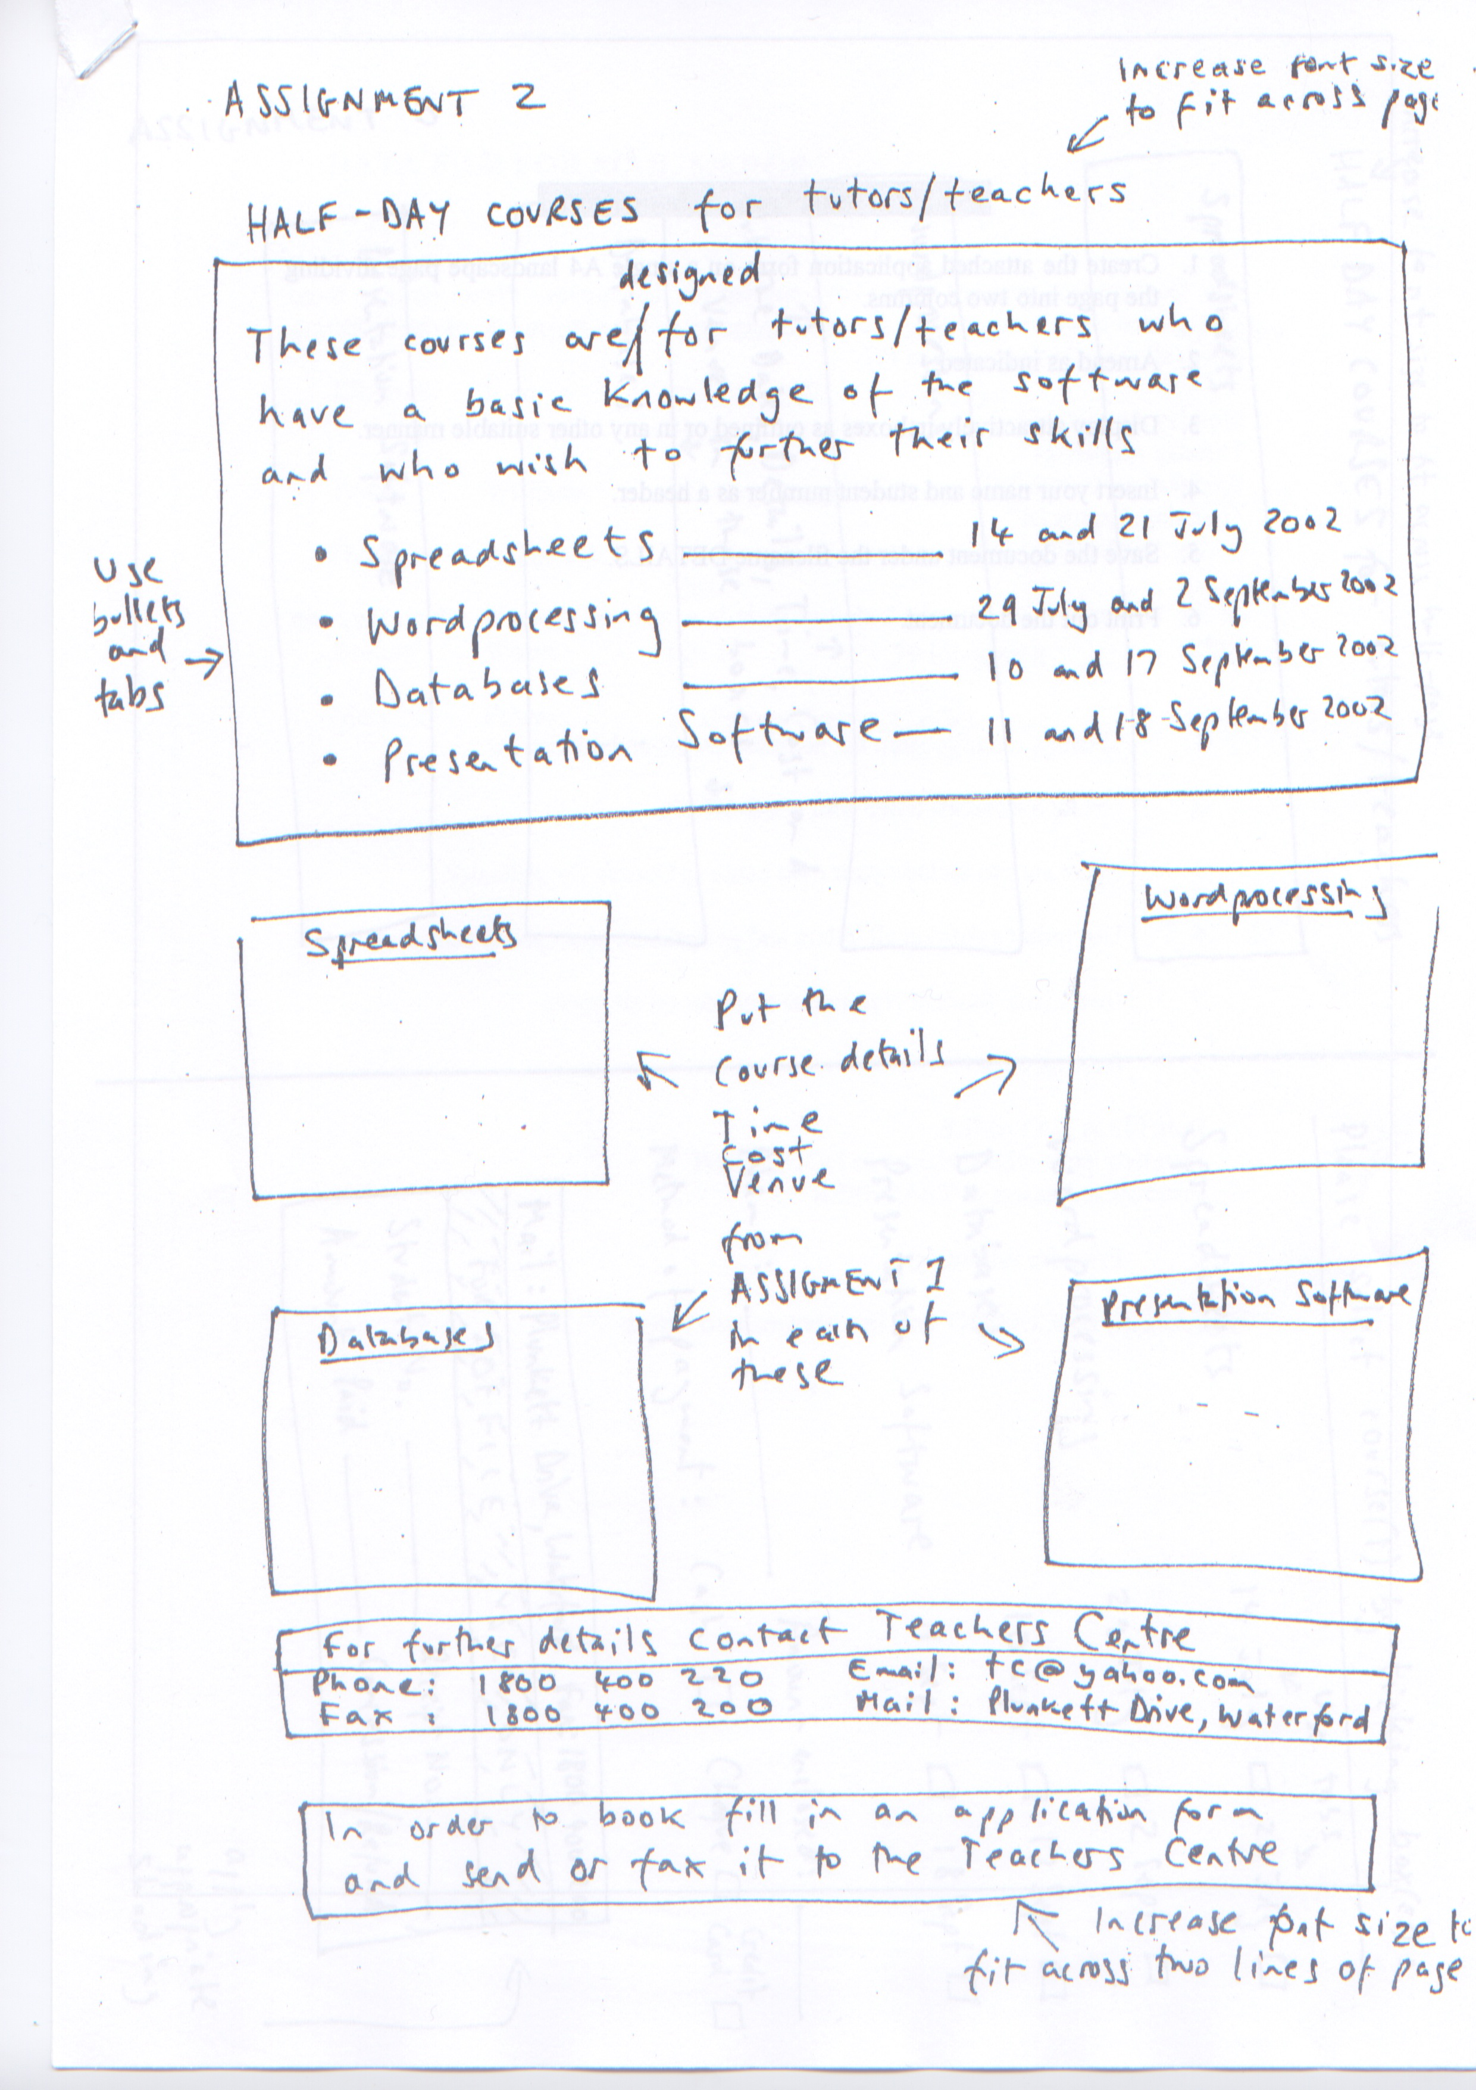

# Assignment 3

1. Open your Final Assignment document.
2. Insert the heading Assignment 3: Application at the top of page 5. Format it as Heading 1.
3. Set out the document below on a single A4 landscape page of your Final Assignment document.
4. Format the page into two columns.
5. Display attractively in boxes as outlined or in any other suitable manner.
6. Take care of pagination.
7. Proofread and correct where necessary. Pay particular attention to spelling and grammatical errors.
8. Insert your name and student number as a header.
9. Save the document.

# Assignment 3: Application

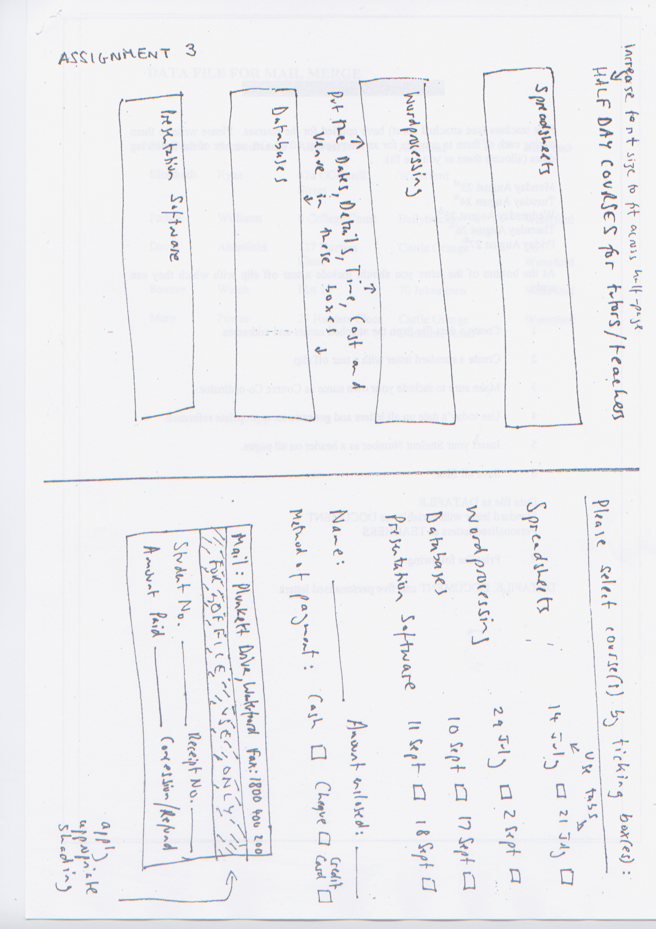

# Assignment 4

Five teachers have applied for a PowerPoint course in WIT’s School of Education. Please write to each teacher and invite him or her to attend for an interview at 10.00am on one of the following dates:

Monday December 12th

Tuesday December 13th

Wednesday December 14th

Thursday December 15th

Friday December 16th

At the bottom of the letter you should include a tear-off slip with which they can reply.

1. Open your Final Assignment document.
2. Insert the heading Assignment 4: Mail Merge at the top of page 6. Format it as Heading 1.
3. Insert a page break.
4. Create a datafile using the names and addresses in the table below.
5. Create a template letter with a tear-off slip.
6. Include your own name as the course co-ordinator.
7. Use today’s date on all letters.
8. Take care of pagination.
9. Proofread and correct where necessary. Pay particular attention to spelling and grammatical errors.
10. Insert your name and student number as a header.
11. Generate the mail merge letters.
12. Save the template letter.
13. Copy the template letter to your Final Assignment file.
14. Copy the five generated teachers’ letters to your Final Assignment file.
15. Upload your datafile (.mdb file) to Moodle.
16. Update your Table of Contents page and upload your completed Final Assignment file to Moodle.

|  |  |  |  |  |
| --- | --- | --- | --- | --- |
| **First Name** | **Second Name** | **Address 1** | **Address 2** | **Address 3** |
| Elizabeth | Ryan | 42a O’Conell Street | Waterford |  |
| Paddy | Williams | 8 College Court | Ballytruckle | Waterford |
| David | Atkins | 127 Hunters Close | Castle Grange | Co. Waterford |
| Saiorse | Walshe | Flat 10 | 70 Johnstown | Waterford |
| Mary | Power | 27 Dunmore Road | Waterford |  |